Heavy Weight #2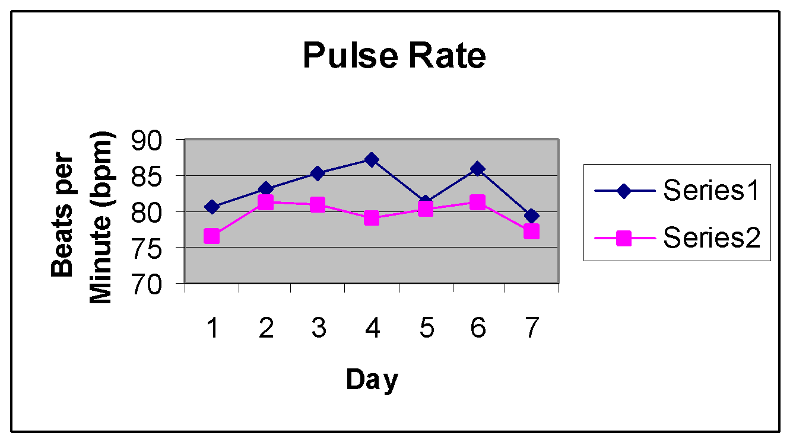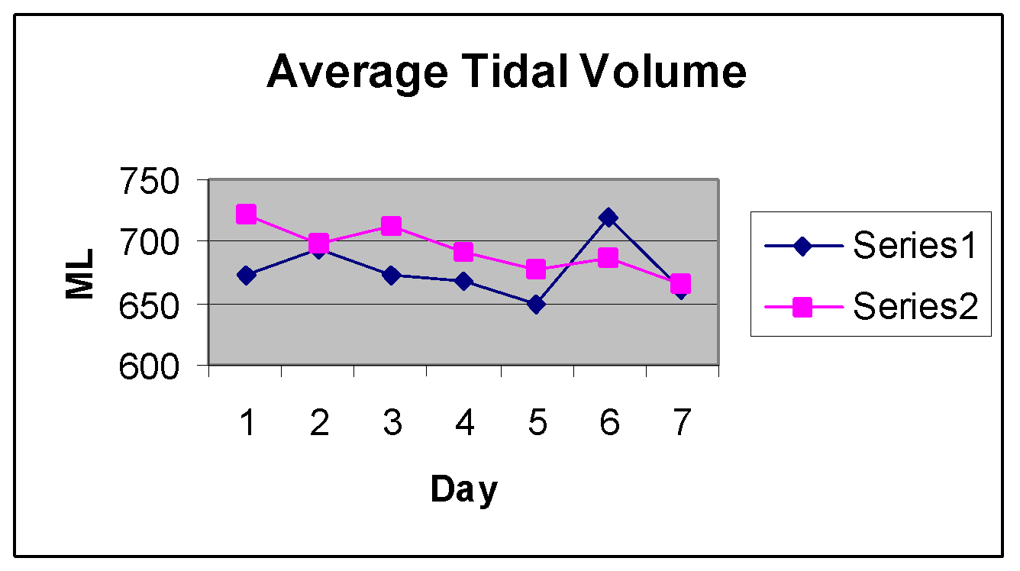

**Series#1 w/o strip; Series #2 w/ strip**

# Series #1 mean: 83.2431 bpm; Series #2 mean: 79.4545 bpm

The Series #2 has a probability of .0224 of occurring by chance when compared to the Series #1 mean. This gives strong evidence that the nasal strip decreased the subject’s pulse rate.

Series #1 mean: 676.3827ml; Series #2 mean: 693.2137ml

The Series #2 mean has a .036 probability of occurring by chance when compared to the Series #1 mean. This gives strong evidence that the nasal strip increased the subject’s tidal volume.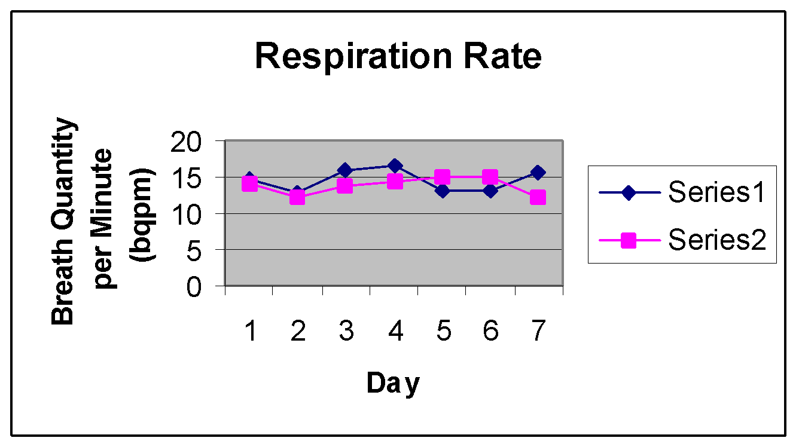

Series #1 mean: 14.5748 bqpm, Series #2 mean: 13.669 bqpm

The Series #2 mean has a .0135 probability of occurring by chance when compared to the Series #1 mean. This gives strong evidence that the nasal strip decreased the subject’s respiratory rate.

Series #1 mean: 295,244.2773 ml; Series #2 mean: 284,900.432 ml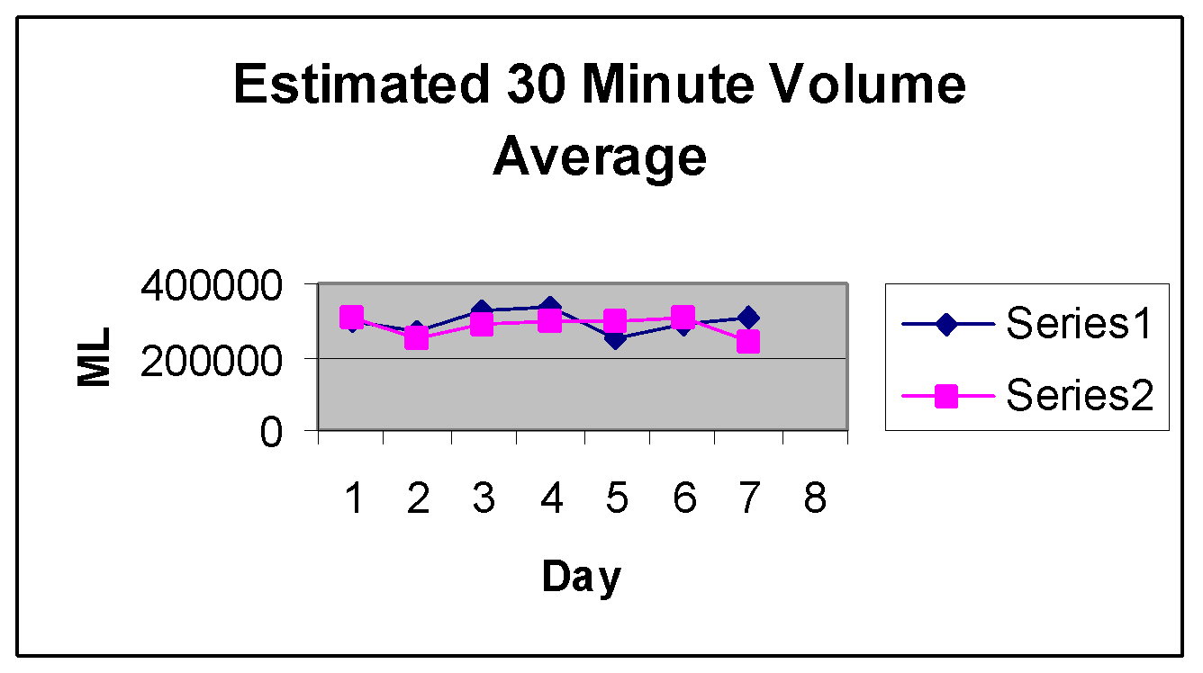

The Series #2 mean has a .221 probability of occurring by chance when compared to the Series #1 mean. This shows weak evidence that the nasal strip either increased or decreased the subject’s 30 minute volume.